**Unit Testing with Jenkins - pytest or JUnit**

By:

Nirmaan Goyal

February, 4th 2024

**Link to my git repository:** <https://github.com/nirmaangoyal/Unit-Testing-with-Jenkins---pytest-or-JUnit>

Mathutils.py

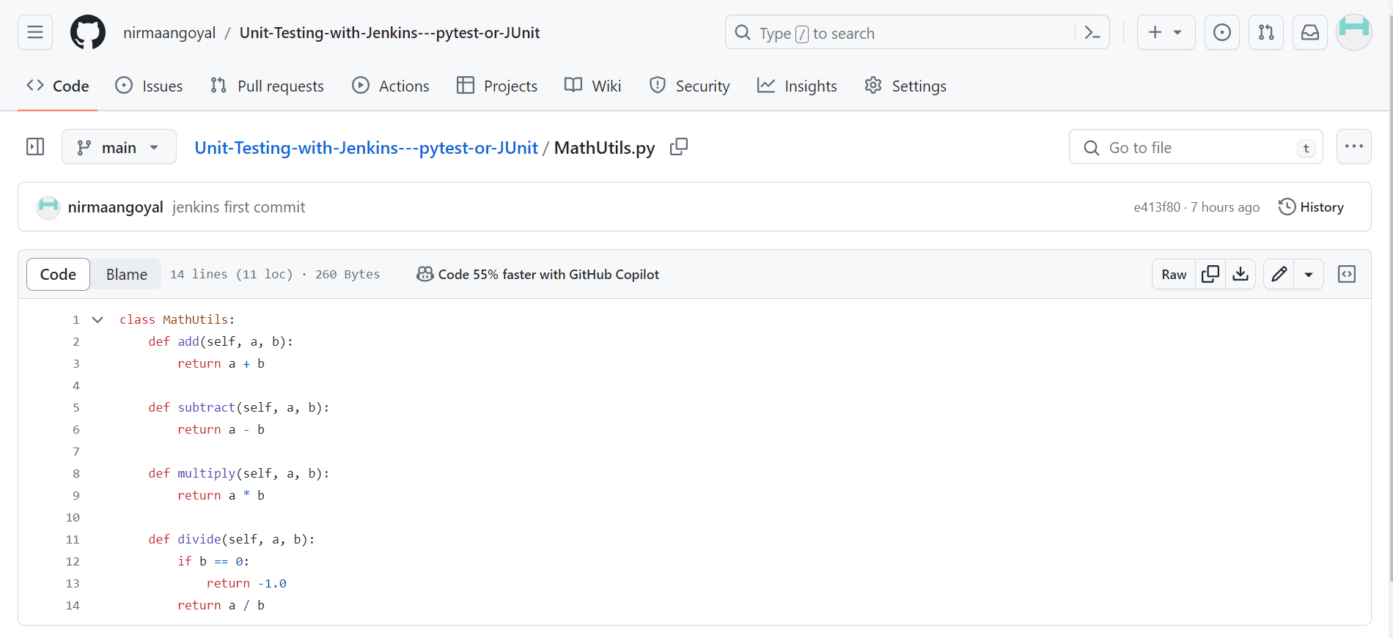

Test_math_utils.py

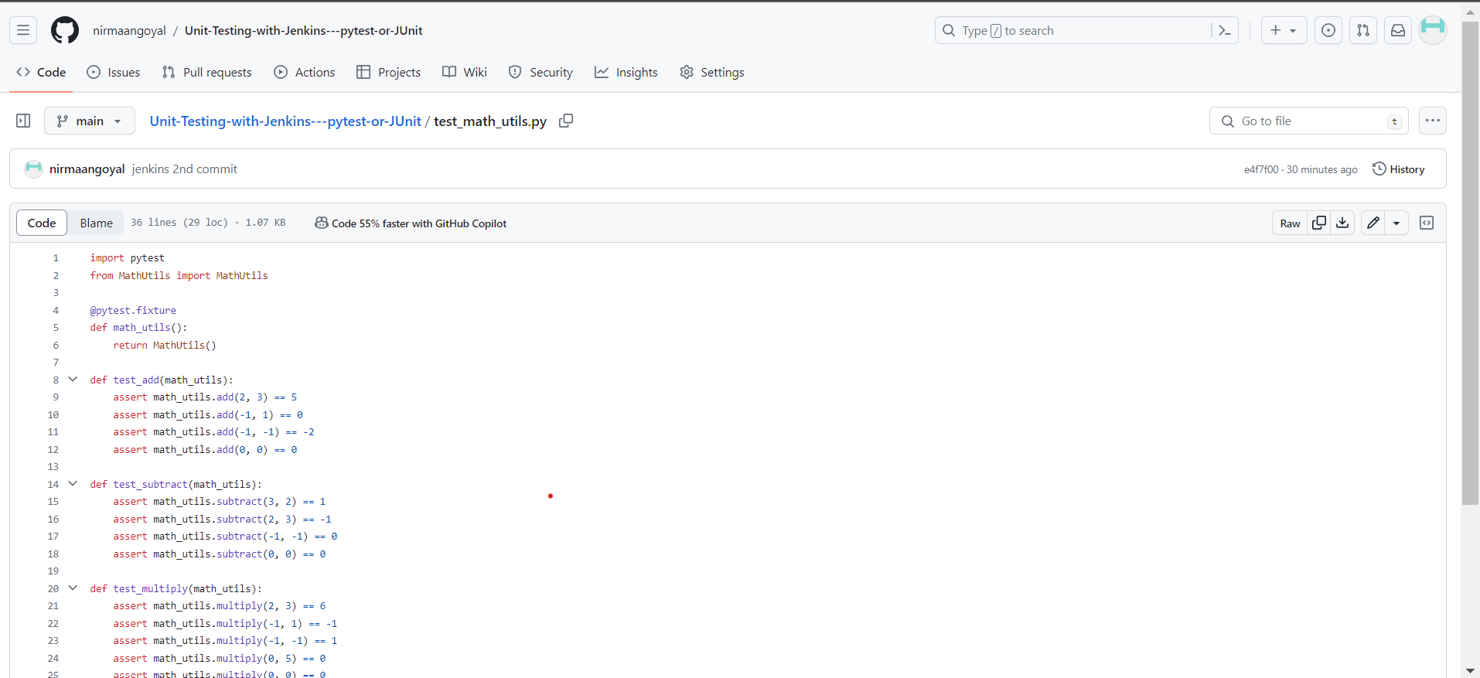

My Jenkins pipeline configuration for checkout, build, test and posting the result in a user-friendly manner.

**post stage will always happen irrespective of success or failure.

pipeline {

agent any

stages {

stage('Checkout') {

steps {

checkout scmGit(branches: [[name: '*/main']], extensions: [], userRemoteConfigs: [[url: 'https://github.com/nirmaangoyal/Unit-Testing-with-Jenkins---pytest-or-JUnit.git']])

}

}

stage('Build') {

steps {

git branch: 'main', url: 'https://github.com/nirmaangoyal/Unit-Testing-with-Jenkins---pytest-or-JUnit.git'

bat 'python3 MathUtils.py'

}

}

stage('Test') {

steps {

bat 'python3 -m pytest --junitxml=results.xml'

}

}

}

post {

always {

junit '**/results.xml' // Publish JUnit test results

}

}

}

Screenshot of my build history with stage view.

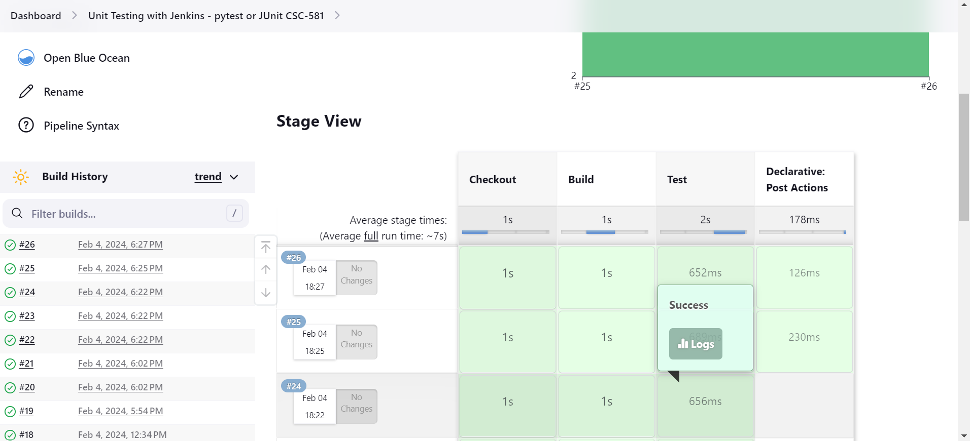

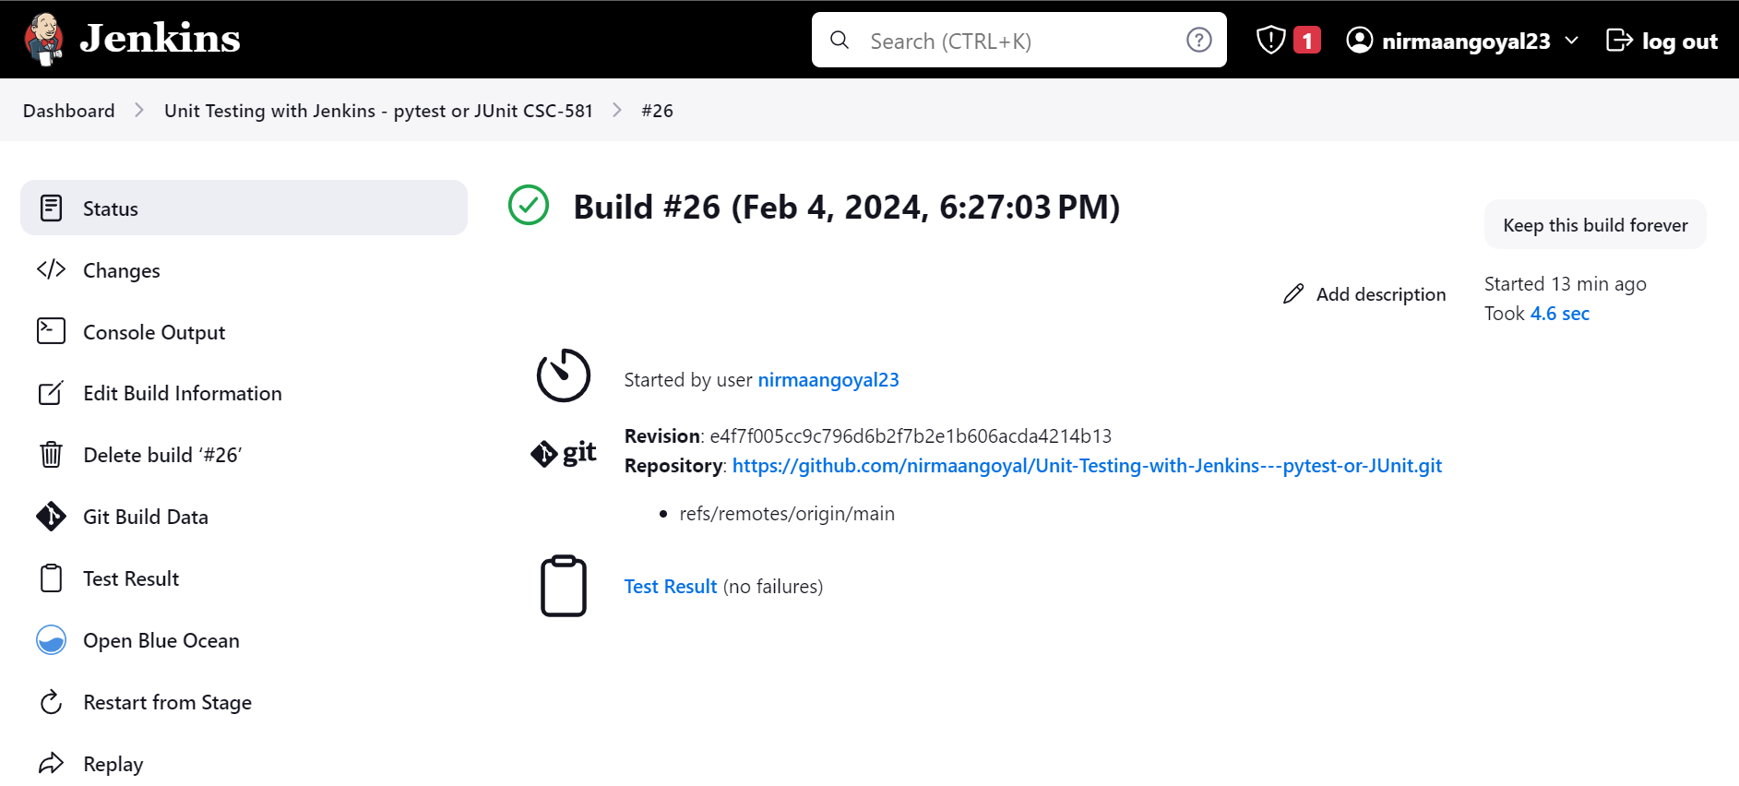

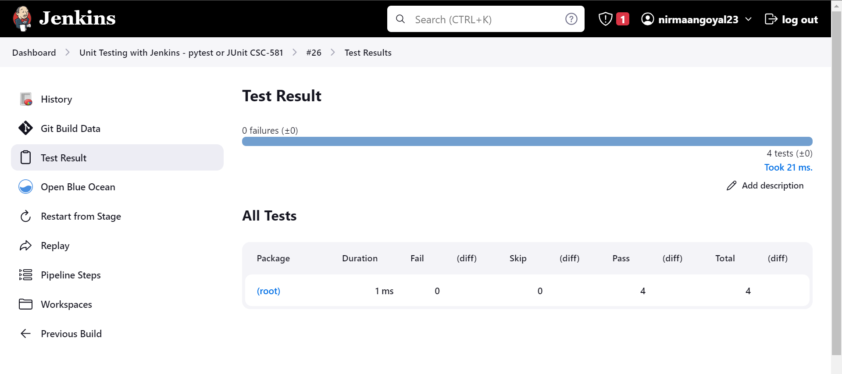

Results.xml file for more detailed view

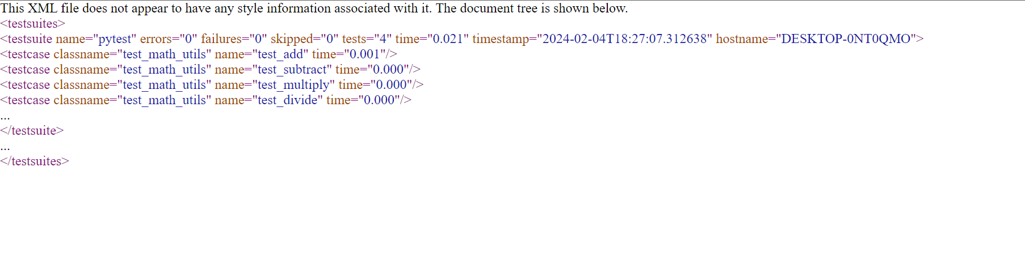

I wasn’t able to trigger the Jenkins job to run automatically whenever changes are pushed to git as I am running Jenkins on my localhost.